CALL FOR POSTERS
The National University of Public Service (NUPS) together with the related Departments of the Association of Hungarian PhD and DLA Candidates, with the Advanced Colleges of the NUPS and with the MHTT Kápolnai Pauer István Youth Club are organizing their traditional poster competition, called
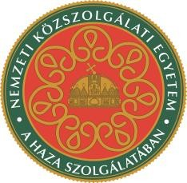
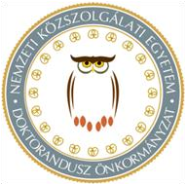
Gateway of Science - Poster Contest and Exhibition
We are proud to announce that one section of the poster competition is part of the European Cyber Security Month (ECSM) again.
One section is also dedicated tot he NATO70 anniversary.

The event is a great opportunity for young researchers to publish their results. Best posters will be exhibited, and best BA and MA applicants may get an opportunity to present their research in an interdisciplinary PhD conference at NUPS in November. Printing costs are covered by the organizers.
Opening ceremony will start at Duna Palace on the
5th November 2019 16.00

Deadline for application and poster submission:

10th October 2019 23.59

Application and submission: dok@uni-nke.hu

Posters will not be accepted after the deadline.
Applicants who want to apply for the European Cyber Security Month (ECSM) section must use template, called: TEMPLATE19.ECSM.pptx.
Applicants who want to apply for NATO70 section must use template, called: TEMPLATE19.NATO.pptx.
All other applicants must use template, called: TEMPLATE19.pptx.
Please note, that submission does not automatically mean participation in the poster exibition. Posters go though a reviewing process and the best posters will be printed.

